Placing orders in Unimarket

It is important to confirm you have money in your budget to place the order.

These are the steps to confirm budget money in Banner.

1. Go to [https://inside.manhattan.edu/index.php?test=1&q=&hPP=200&idx=TasksServices&p=0&hFR[category][0]=Featured&is_v=1](https://inside.manhattan.edu/index.php?test=1&q=&hPP=200&idx=TasksServices&p=0&hFR%5bcategory%5d%5b0%5d=Featured&is_v=1)
2. In the keyword search type in Banner

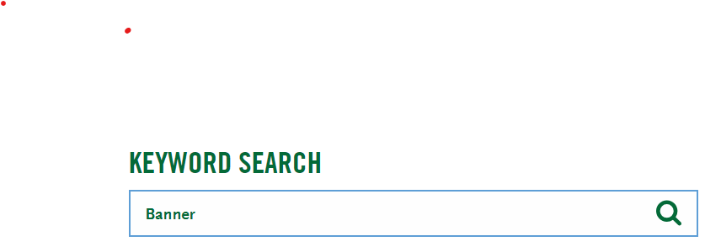

1. Click on Banner ERP

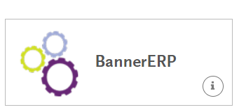

1. Click on Banner 9 mfa

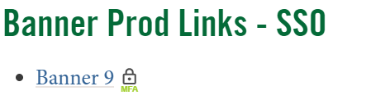

1. In the welcome search field type in FGIBDST

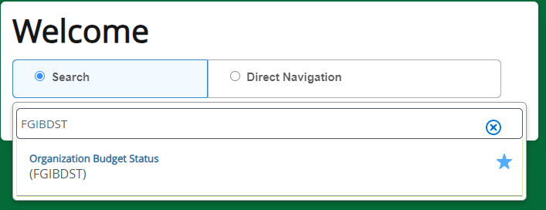

1. Next place your org # organization data field then click on Go

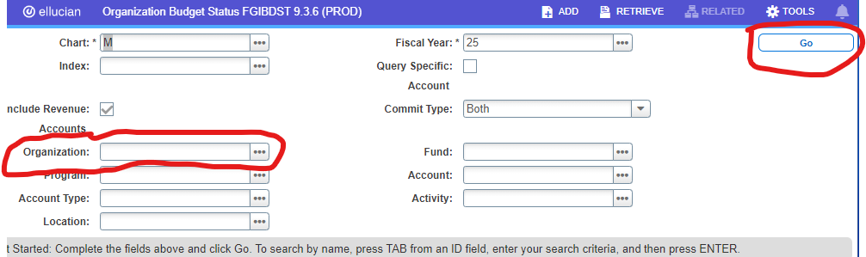

1. The next screen will be all the budgets associated with your entered organization #.



1. If the available balance exceeds the amount on your purchase request then proceed to Unimarket to enter the order.
2. If the available balance is below you purchase request then please work with James Grate

Director of Financial Planning and Analysis Finance [jgrate01@manhattan.edu](mailto:jgrate01@manhattan.edu) to adjust your budgets to accommodate your purchase request.